**Product listing page….**

**These are points that you need to implement**

* Keep 4 cards in one row (desktop view)
* Keep 2 cards in one row (Mobile view)
* Card Hover Effect. (<https://www.zivame.com/winter-must-haves/lightwinter.html?trksrc=navbar&trkid=l2>)
* Image Hover Effect (<https://www.amantelingerie.in/collections/nightwear>)
* Add button for add to card
* Keep appropriate Height as in the reference website link.
* Decrease size, set appropriate size in desktop and mobile view

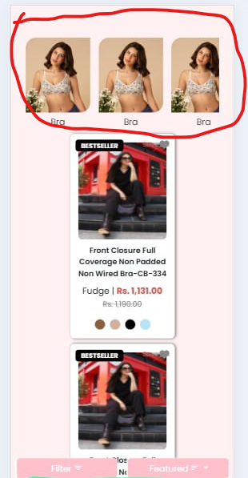

* Remove Container, cards should be shown in full width left right.
* Remove internal padding of image (left-right padding)
* Remove filter row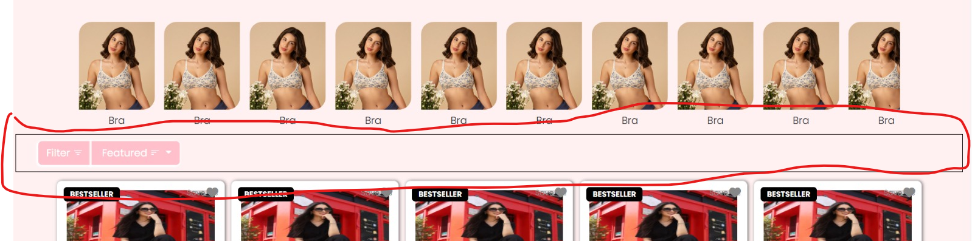
* You can use this kind of filter ([https://www.zivame.com/winter-must-haves/lightwinter.html?trksrc=navbar&trkid=l2)](https://www.zivame.com/winter-must-haves/lightwinter.html?trksrc=navbar&trkid=l2))
* Or this one [https://www.amantelingerie.in/collections/panties](https://www.amantelingerie.in/collections/panties*)

**Product Detail page….**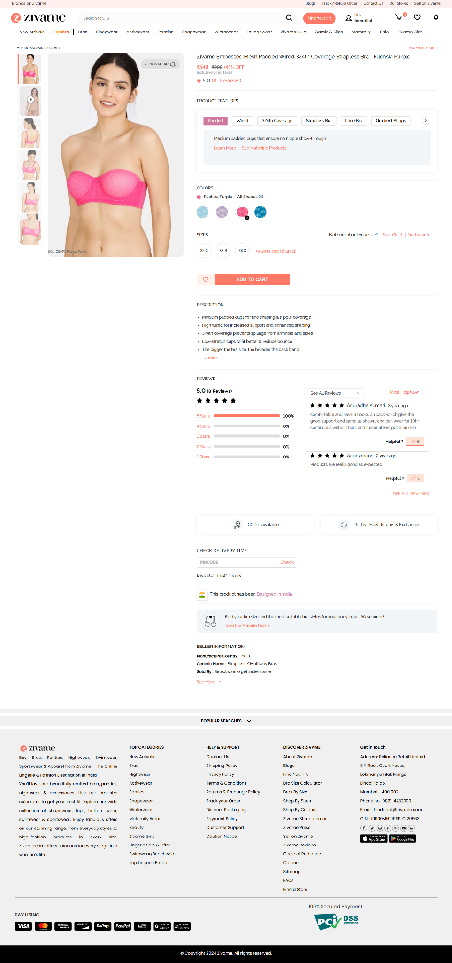

* Create Design As its showing in this website ([https://www.zivame.com/zivame-embossed-mesh-padded-3-4th-coverage-wired-strapless-bra-fuchsia-purple.html?trksrc=similarcolors&trkid=product#](https://www.zivame.com/zivame-embossed-mesh-padded-3-4th-coverage-wired-strapless-bra-fuchsia-purple.html?trksrc=similarcolors&trkid=product)?)
* Add all features as given in this page
  + Add to card
  + Color hover image show
* Please go through whole page before start working.
* Same Add to card should work (If size not selected then show this)
* 